Series: Unwrapped
Message: Gift of Hope December, 11, 2016
Luke 1:26-38, 46-56

Despair is a lie. Genesis 3:10-13
Despair is a thinking error.
Despair: Psalm 40:12; John 8:43-47
- Silent
- Joyless
- Is Immobilizing
- Is a pestilence

Hope is recognizing the reality that God is greater than myself and my circumstance.

Hope
Romans 5:1-2, 8:24-25; John 8:12; 1 Peter 3:1-15;
1 Thessalonians 5:8; Hebrews 6:17-19; Hebrews 10:23-24

- Speaks
- Claps
- Is Empowering
- Is irresistible (light)

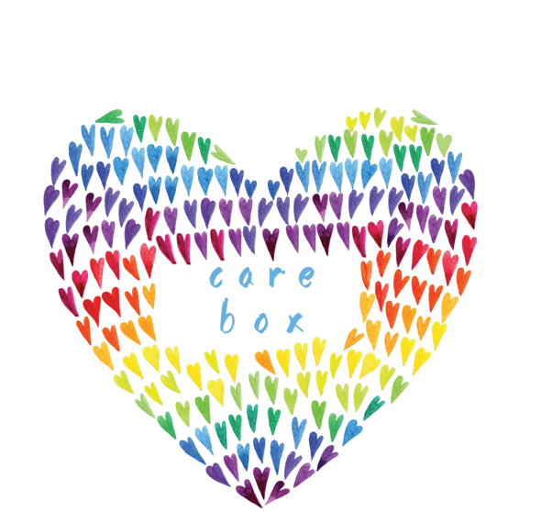

BOXES FOR KIDS ENTERING FOSTER CARE
WHILE WAITING IN A DEPARTMENT OF SOCIAL AND HEALTH SERVICES OFFICE
Up to 75% of children coming into foster care in the tri-county area must wait in an office for 1-2 hours while a social worker calls to find them a suitable foster home placement. Most kids have a few items in a plastic garbage bag, but often times these kids have absolutely nothing to call their own. Understandably, this is a time of high anxiety for children as they’ve recently been removed from their home and are being moved to a new, unknown foster home. Caseworkers (who are truly doing the best job they can with very limited resources) are left scrambling to occupy the child in the DHS Child Welfare office.
As a Real Life Church Community, we can come alongside these caseworkers and children. While we can’t change the sad circumstances these children have already experienced, we can at least provide a tangible source of comfort and hope for the journey ahead. The notion of a Care Box is a simple one. While the child is waiting, the social worker hands the child a box of age-appropriate items to occupy their time while in the DHS office. This box is then theirs to keep and take with them into their new foster home. Since many children enter foster care with very few belongings, the psychological importance of owning a box full of nice things cannot be underestimated!
We will be collecting money (please designate your donation) now through December 18th to purchase the items for these boxes, which will be put together by children and their families involved in Advent Conspiracy Kidz Life Edition.

